Jordan 750.5 Charger.
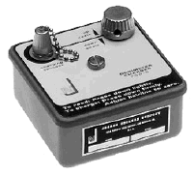
The 750 is a compact lightweight instrument designed to charge direct reading pocket dosimeters. (Battery not included)
POWER: 1 ea. "D" Cell battery
BATTERY LIFE: Capable of recharging dosimeters thousands of times.
SIZE: 4"(10.2 cm)W X 4"(10.2 cm)L X 3"(7.6 cm)H
WEIGHT: 8.6 oz (254 grams)
The dosimeter has a built-in string electrometer and ion chamber. The Jordan 750.5 Charger is used to impress a charge on this ion chamber. A zero position on the built-in scale will indicate that the dosimeter is fully charged. Radiation passing through the chamber will cause the charge to leak off in proportion to the amount of radiation and move the electrometer string upscale accordingly. This upscale position indicates the amount of radiation exposure.
The Jordan 750-5 Charger is a compact lightweight charger designed to charge most direct-reading quartz fiber dosimeters. This instrument features a fully transistorized and printed circuit board. Power required for operation is furnished by a single "D" flashlight type battery, capable of recharging dosimeters thousands of times before replacement is necessary, thus making it an economical and reliable charger to operate. A safety spring located in the charging socket of the Model 750-D prevents damage to the dosimeter in the event that excessive pressure is exercised when recharging. Both moisture-proof and dust-proof, the charger also features a protective cap to prevent any moisture or dust from accumulating in the charging socket when not in use.
Specifications
Model | 750-5A
Range | 200 to 250 volts
Battery Complement | 1.5 v "D" cell, carbon
Mil - Spec | FSN 665-00-856-8813
Weight | 1.25 lbs
Shipping Weight | 2 lbs
Volume | .1 cubic feet
Finish | light and dark grey enamel
Dimension | Approx. 4.1 x 4.1 x 2.75 inches
Operating Conditions
Temperature | -20 F to + 140 F
Humidity | No effect, unit has water and dust tight seals
Altitude | Independent of pressure changes from sea level to over 50,000 ft
Construction | Cover: Heavy aluminum casting Case: Drawn Steel. (0.025 c.r.s.) Built to meet rigid Military standards requirements for extremes of temps, altitude, shock and Vibration

Instructions on the use of zeroing (charging) the Direct Reading Pocket Dosimeter with the Jordan charger
Operation
Accumulated radiation is read directly on an internal calibrated scale. A Dosimeter Charger ( such as the Jordan 750-5) is required in order to return the dosimeter to zero after each exposure period if desired.

One end of the dosimeter contains an optical eye-piece; the opposite end is sealed by a diaphragm switch which houses the insulated steel charging pin. The instrument is charged (set to zero) by pressing the charging pin onto the charging socket on the charger.

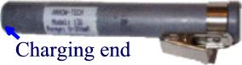
Arrow-Tech Model 138 , 0 - 200 mR

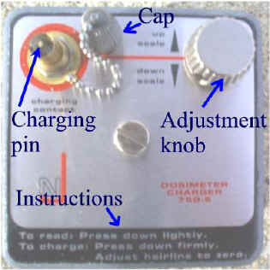
Jordan 750-5 charger
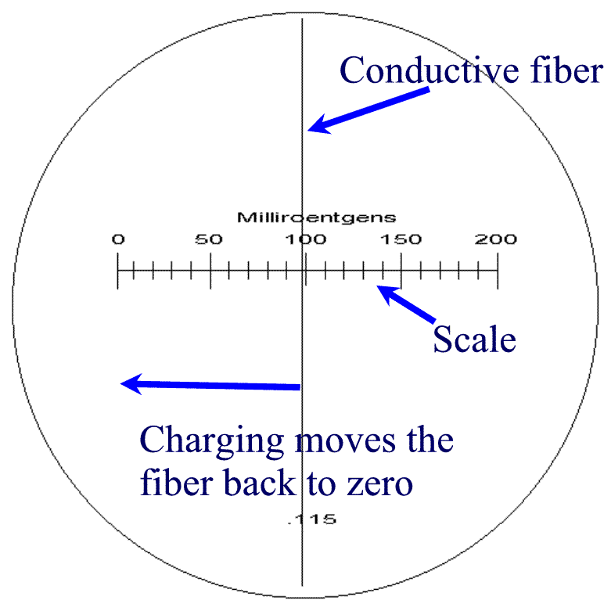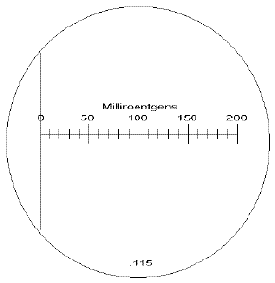
After properly charging the dosimeter, the fiber will remain on zero.
The Charging Process
FIRST Check to see if the light comes by reading a dosimeter, if the light does not come on it could mean there is no battery inside the charger. Make sure the battery is OK before placing it into the charger.

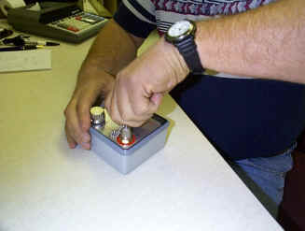
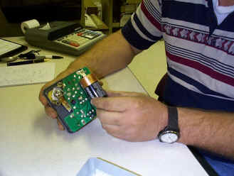

Removing cover to check battery
Placing a battery into the Jordan charger
Reading a dosimeter: Remove the cap on the charging socket by unscrewing the cap. Then press down lightly with the dosimeter on the charging socket. The light should come on.
When the charging pin is pressed firmly into the charging socket (receptacle) on the charger, the pin contacts the electrometer frame. Sufficient voltage is applied to charge up the dosimeter and to set the fiber to zero. The charger should be used to recharge the dosimeter to zero before each use of the instrument.
A. While pressing the charging end of the dosimeter firmly down in the receptacle of the charger, adjust the "down-scale/up-scale" control on the charger, while looking through the dosimeter at the light that comes on until a zero reading is indicated IF the fiber is not moving, press the dosimeter farther down in the receptacle and try again.

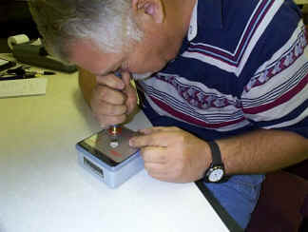
Here you see Ron "Zeroing" a dosimeter, notice his left hand on the adjustment knob. After he has Zeroed the dosimeter, he lets up just a little to keep the light on and see if the fiber is still on zero.

B. At times, a transient "kick" is experienced when zeroing the dosimeter. The charging contact of the charger automatically compensates for the kick when the dosimeter is with drawn slowly from the contact. You can see this effect by holding the dosimeter on the charging contact while looking into the instrument. Withdraw the instrument slowly. You will note that just before the light turns off, the hairline will shift. With a little practice the hairline can be made to shift so that its final position coincides with the zero line. Optimum performance is obtained when electrostatic kick is compensated for in this manner. The hairline will remain on or near the zero position for long periods when not exposed to radiation.
C. When resetting the dosimeter to zero, the fiber may disappear and remain hidden. To release the fiber, slowly turn the "down scale / up scale" knob until the fiber reappears..
D. At the end of the designated period of exposure, the accumulated amount of radiation can be read directly from the scale by looking through the eye-piece while pointing the dosimeter towards an external light source.
Preventative Maintenance
The dosimeter is an extremely sensitive instrument and, although it has been constructed for rugged use, it should receive the same care as a wristwatch. Since these dosimeters are hermetically sealed at the factory, the instrument cannot be repaired or adjusted in the field. Therefore, if malfunctioning of an instrument is experienced, it should be returned to the factory. The dosimeters may be maintained in prescribed operating condition by simply cleaning the eye.lens and the charging switch diaphragm which clean water and a cloth free of lint and grit. Extra care should be taken to make sure the charging switch diaphragm is absolutely free of lint, dirt, or moisture at all times.
Caution
Do not insert any sharp objects into or tamper with parts in the charging switch recess, as irreparable damage may be done to the instrument. Also, do not clean lenses or the charging switch with any solvent other than clean water as the plastic materials can be affected by many solvents.

